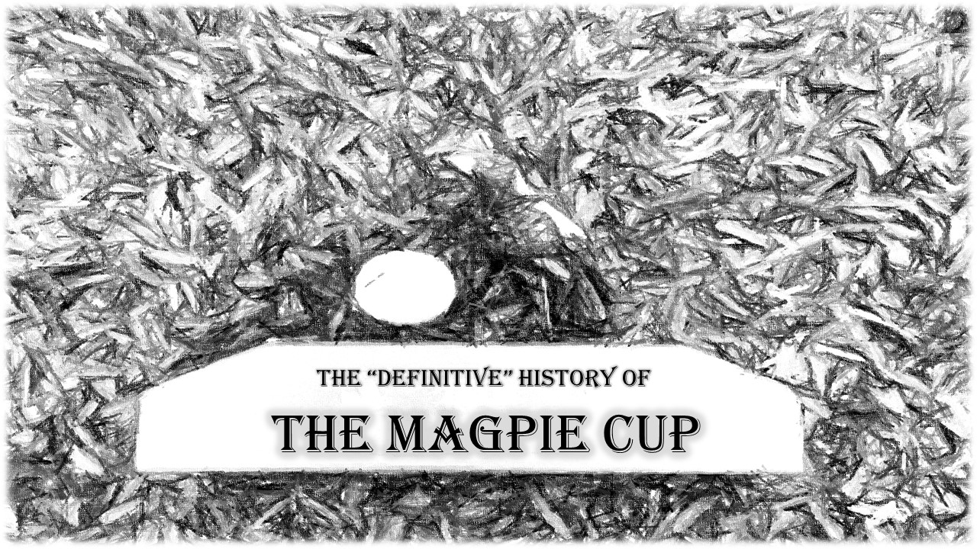
(There may be some artistic licence taken with certain characters and events, and by some I mean a lot, and by a lot I really mean A LOT, but this is sort of what happened, at least the bit about the magpie is %100 true)
The date and even the year of the very first Magpie Cup is lost to the hazy mists of history, no one even remembers who won. Everyone has a different story about how it all began, all of which only agree on one thing, the eponymous magpie and the atrocious golf shot which ended with that magpie in a wheel barrow. Of course as I was there when the game was organised, well obviously I can say with complete honesty that my version of events is 100% accurate and all the other stories are fanciful tales full of lies. So this is the DEFINITIVE truth...probably.
It all began in the Jamberoo Bowling Club, I was working behind the bar with Mitch Vine, a man who has long since left the Club's employ, a great bloke. We were going about our business, t'was a cheery, sunny, early summer evening, and the Club was bustling, there was a cosy atmosphere, which was suddenly shattered. For who should walk into the bar but Doug Smith, as he came inside, the sky darkened, the atmosphere turned sour, dogs barked, thunder roared, and a murder of crows swarmed onto the bowling greens.
Doug haughtily strode into the bar, contemptuously glancing around at the good, kind and humble patrons of the Bowlo and proclaimed out loud, that he had just played the greatest game of golf ever played by a person, and that because of this he was superior to every single person in the place, perhaps, the whole world (I may be slightly embellishing what was said here, but this was the basic gist).
Mitch and I looked at one another, we are not men who would stand idly by while Doug was so brazenly boasting, when we were both aware that Doug is a terrible golfer. So both of us, as one, cried out “Bullshit!”
Doug swung his malevolent gaze towards us “Oh, so you think YOU could defeat me in a game of golf? HA! I challenge you fools to a match. Prepare to taste bitter defeat.”
The Villianous Doug Smith 1

Without even needing to so much as glance at one another we both nodded “Challenge accepted old man. We shall see who tastes defeat”
And with that the game was set.
So we ended up playing sometime between Christmas and New Year, Doug invites his two son’s Ryan and Grant to play as well (both better golfers than Doug) and to even up numbers and because he loves golfing (NOT because he is a better golfer than me) I invite my brother Craig.
Through a series of events, which may have involved me celebrating our upcoming victory against Doug, a bit too much, I ended up being late for the game. I caught up to them on the fourth tee at Jamberoo Golf Club, where both of my team-mates were stripped down to their boxer shorts due to losing a bet on the third hole. Knowing the importance of proper hydration Doug, Grant and Ryan had brought along a wheelbarrow full of ice and liquid refreshment. The fourth hole was played, minus pants for some of us, and then, pants re-donned, we headed to the fifth tee.
This is where it happened, the shot that created the Magpie Cup, Grant walked purposefully onto the tee and struck, what can only be described as, a bloody awful golf shot. It screamed along, mere inches above the ground, and slammed into a poor magpie who was just minding their own business. The poor bird was bowled over from the impact and ended on its back, feet pointed at the sky…we were sure Grant had killed the poor thing…however we got to it and the magpie was alive, just horribly dazed from being winged by a worm-burning golf ball. So we picked up the bird and put him on the front of the wheelbarrow. And that is where he sat for the whole of the fifth hole, as our mascot. Then as we moved to the sixth tee, his head must have cleared, and he flew off into legend…and the Magpie Cup was born.
We had such fun that day that we decided to keep doing it, so every year between Christmas and New Year’s Eve we pick a date, invite everyone we know, and everyone we don’t, and play a game of Ambrose, with random teams drawn from a hat. The second Magpie Cup had maybe 10-12 players, and it has grown every year since. At some point Doug stopped being the villain and decided that all these folks coming to play golf could probably do some good, and started to collect money for The Fight for Connar Foundation. These days the Magpie Cup is a great day, no prizes, just a bunch of people getting together to play some golf, raise some money for charity, meet new people and just have a grand old time.
We hope to see you at the next one!

